Airfoil Induced Vortices

Samuel Lee

PH-235 Physics Simulations

The Cooper Union for the Advancement of Science and Art

# Motivation

Vortex generation due to pressure differences is a phenomenon commonly seen at the end of airplane wings as the higher-pressure flows under the wing are drawn towards the low-pressure region above the wing in a direction normal to the freestream. This fluids phenomenon causes two major problems: wingtip vortices negatively affect the thrust generated by the airplane and the wingtip vortices grow over time and space behind the airplane, potentially affecting any other vehicles behind it. Studies have been performed by many, including Anderson et al, that show that vortices form along the edge of the airfoil and then merge downstream into a single coherent wingtip vortex [1]. A solution to the negative effects of wingtip vortices, are winglets, which converts some of the vortex energy into thrust and reduces the intensity of the vortices. This study will focus on vortices generated without winglets, as shown on the left-hand side of Figure 1, which will improve my own understanding of vortices and allow me to better understand the design of winglets and other flow control methods used to mitigate the negative effects of vortex generation.

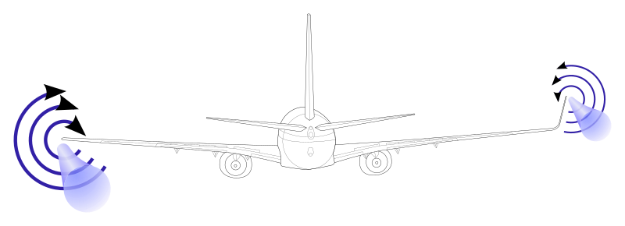

Figure 1: Vortex without winglet on left and vortex with winglet on right. Source: Olivier Cleynen.

# Background

## Fluid Mechanics

Fluid mechanics, from a general standpoint, can be solved using a set of partial differential equations called the Navier-Stokes equations, which consists of equations of mass, momentum, and energy conservation, stating that those three quantities must be held constant within a closed system.

$$\frac{∂ρ}{∂t}+∇\left(ρu\right)=0$$

$$\frac{∂}{∂t}\left(ρu\right)+∇\left(ρuu\right)=0$$

$$\frac{∂}{∂t}\left(ρE\right)+∇\left(ρEu\right)=0$$

$$ρ-density$$

$$u-velocity vector$$

$$E-energy$$

These three equations can be solved using boundary and initial conditions in 1D, 2D, or 3D. While these equations define the nature of the flow in or around a medium, there is a further study of vorticity, which can be defined as the curl of the velocity vector. An example of vorticity is the circular flow as a bathtub is drained.

$$ω=∇×u$$

Vorticity reveals the rotational nature of a flow and can be described in time using the following equation.

$$\frac{Dω}{Dt}=\frac{∂ω}{∂t}+(u⋅∇)ω$$

Circulation, or the amount of force that pushes a fluid along a path, can be used to help define vorticity. Using Stokes’ theorem, the circulation can be related to the vorticity, where vorticity is the circulation per unit area.

$$Γ_{∘}=\oint{udl=\iint{ωdS}}$$

These equations are typically solved using the finite volume method in computational fluid dynamics (CFD) software but can also be solved using numerical methods and algorithms.

## Prior Research

Vorticity generated from wingtips is a complex problem that is typically observed through experiments or by running CFD simulations that attempt to model the physical phenomenon. In a study by Estrand et al, experimental and numerical studies were performed on a National Advisory Committee for Aeronautics (NACA) 0012 symmetric airfoil with an angle of attack of 5° [3]. They concluded that vortex wandering in the flow field is caused by instability is caused by the vortex dynamics. This means that many prior experiments performed in wind tunnels that attempted to correct for vortex wandering were actually modifying the flow incorrectly. The numerical study indicated that the temporal instability was coupled with spatial instability, but did the instabilities were not measured or characterized. These studies show that vortex flows are easily observed both in experimental and numerical studies, however, the instabilities in the flow are complex and have yet to be fully characterized and understood.

# Objective

The aim of this project will be twofold: to generate and visualize a wingtip vortex definition based on flow conditions and then use other methods to analyze the generated vortex. The vortex will assume that the vortices have already combined into a single coherent vortex. The first portion of this project will allow the user to define any flow condition and the output will be a visualization of that vortex over space and time. The second portion of the project will allow for further analysis of the vortex including its direction and the velocity field associated with the vortex itself.

# Approach

To generate and visualize a wingtip vortex based on the flow conditions, a set of equations will be used. The equations, in 3D Cartesian coordinates, will use the freestream velocity and pressure difference as input parameters and then output a set of equations that determine the vortex’s shape in space and time. These equations, when solved using Runge Kutta, give the shape of the vortex, where the flow is tangential to the vortex itself.

The second step of analysis involves two steps to obtain the direction and velocity field of a given vortex. The vortex line can be calculated by performing a line integral on the vortex. This should result in a line that follows the center of the vortex as it grows over space and time, thus revealing the direction of the vortex. The velocity field can be obtained by utilizing the Biot Savart law to relate the vorticity to the velocity of the vortex line.

# Vortex Definition

Fluid dynamics problems can be analyzed in multiple ways. One method is to observe the fluid flow by tracking a single fluid particle along the flow path. By defining the position of the fluid particle as it follows a vortex path, the fluid flow can be analyzed. The vortex will first be defined in cylindrical coordinates as a function of the pressure difference generated by the airfoil and the freestream velocity. This is a base case that will exhibit a vortex that grows in size as it travels over distance and time based on the difference in pressure below and above the airfoil, denoted by *dP*, and the freestream velocity, denoted by *vinlet.* The user will have the ability to adjust these two values and eventually be able to input an airfoil geometry

$$r=\frac{dPt^{2}}{2}$$

$$θ=C_{1}t$$

$$z=v_{inlet}t$$

Since vorticity is defined as the pseudo-vector calculated by the curl of the velocity vector, the velocity vector is needed. The velocity can be calculated in Cartesian coordinates by first performing a transformation of the position and then performing a derivative.

$$x=rcosθ=\frac{dPt^{2}}{2}\cos\left(C_{1}t\right)$$

$$y=rsinθ=\frac{dPt^{2}}{2}\sin\left(C_{1}t\right)$$

$$z=v_{inlet}t$$

$$v_{x}=\frac{dPt^{2}}{2}\left(-C_{1}\sin\left(C_{1}t\right)\right)+dPtcos\left(C_{1}t\right)$$

$$v_{y}=\frac{dPt^{2}}{2}\left(C_{1}\cos\left(C_{1}t\right)\right)+dPtsin\left(C_{1}t\right)$$

$$v_{z}=v_{inlet}$$

$$ω=∇×v$$

$$ω=\left(\frac{∂v_{z}}{∂y}-\frac{∂v_{y}}{∂z},\frac{∂v_{x}}{∂z}-\frac{∂v_{z}}{∂x},\frac{∂v_{y}}{∂x}-\frac{∂v_{x}}{∂y}\right)$$

$$ω=\left(0, 0,C_{1}-\left(-C_{1}\right)\right)=\left(0, 0, 2C_{1}\right)$$

A non-zero vorticity vector indicates the presence of rotational vorticity, which is expected. If the vorticity vector were zero, then it would be an irrotational flow, which does not exist in nature and would invalidate the initial vortex definition as a plausible flow path of the fluid particle.

# Analysis

Although the complexity of the polar definition of the vortex is quite low, the goal of this program is to eventually have the functions be equations derived from the Navier-Stokes equations in Cartesian coordinates. For now, the base case described in Vortex Definition will be used. The case will have the following parameters: *vinlet = 165, dP* = 3*.* While the pressure difference was chosen arbitrarily, the freestream velocity in mph is typical of take-off speeds for commercial airliners.

$$v_{r}=dP*t$$

$$v_{θ}=C_{1}$$

$$v_{z}=v_{inlet}$$

Using Runge-Kutta with the velocity equations above, the points for the fluid particle’s position was generated over time and visualized. These points were then visualized using the VPython package.

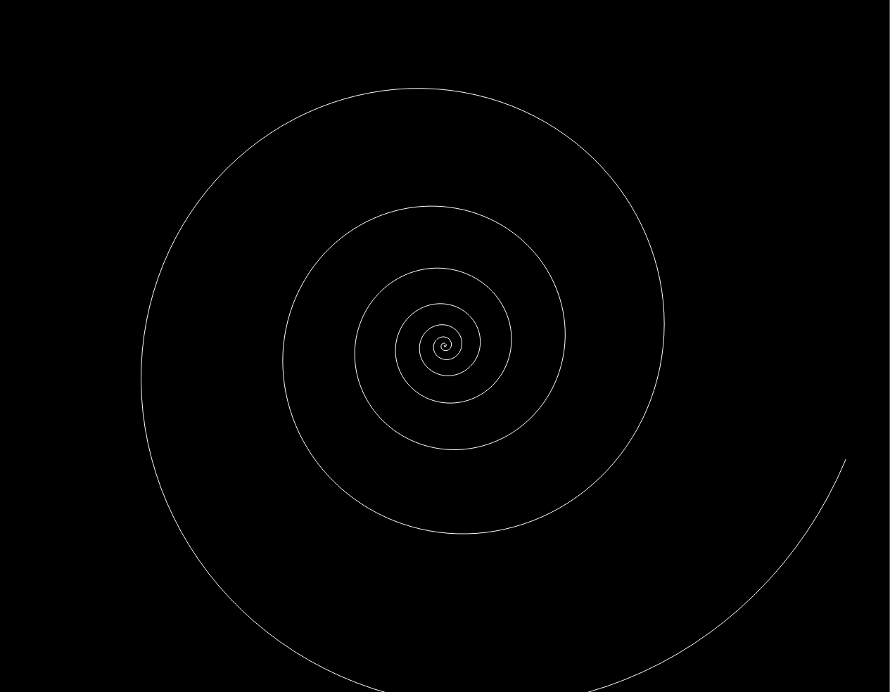

Figure 2: Frontal view of vortex points.

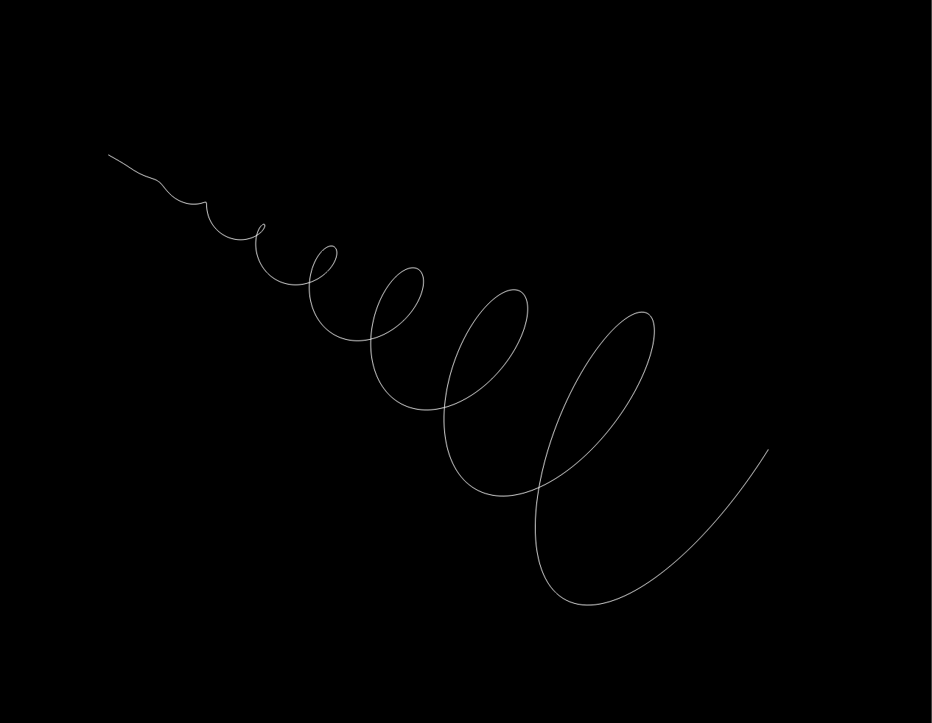

Figure 3: Isometric view of vortex points.

From Figures 2 and 3, the vortex is shown to grow over space and time, as is expected for a wingtip vortex. The conical shape that is generated by the vortex is generally referred to as the vortex cone and is the space within which the vortex and turbulent instabilities exist.

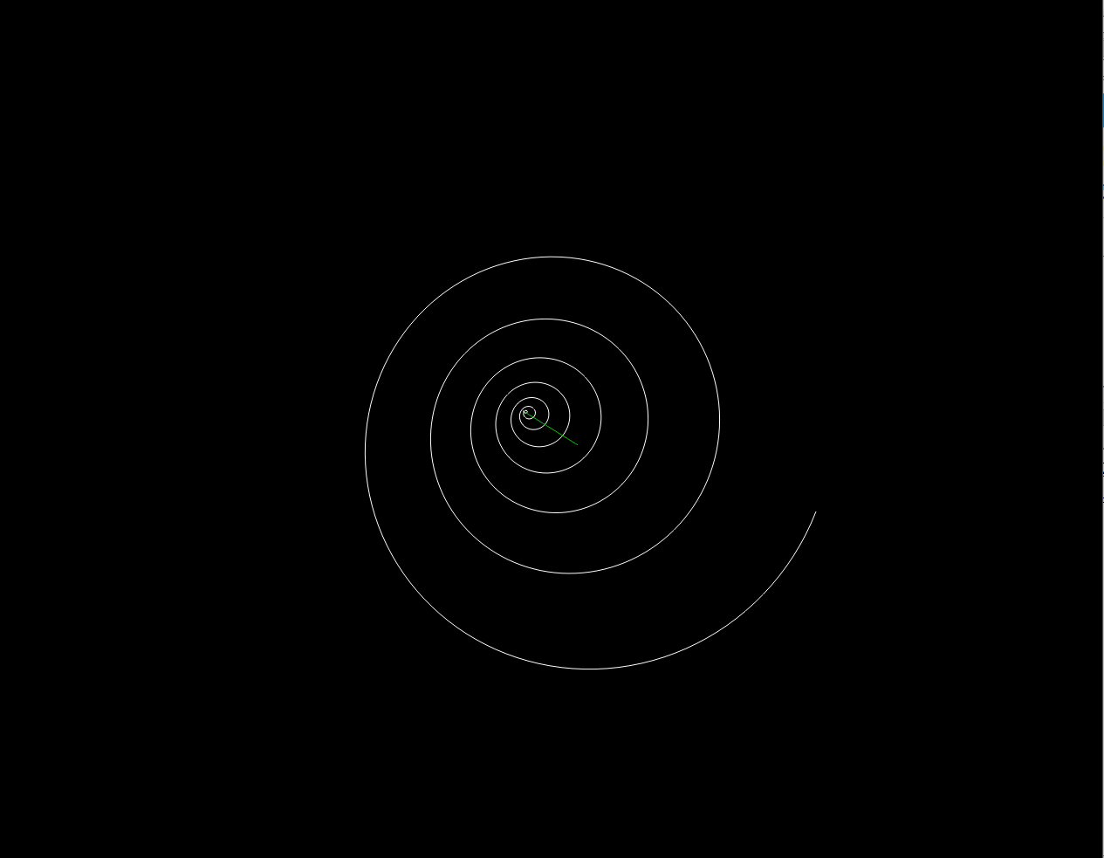

Figure 4: Frontal view of vortex points and vortex line.

The above view of the vortex and vortex line shows that the vortex cone’s growth and oscillation is centered around a midline. This midline, due to the definition of the base case vortex, is located at (0,0,Z). For a more complex case that accounts for gravity and other lateral forces, the midline will follow a nonlinear path.

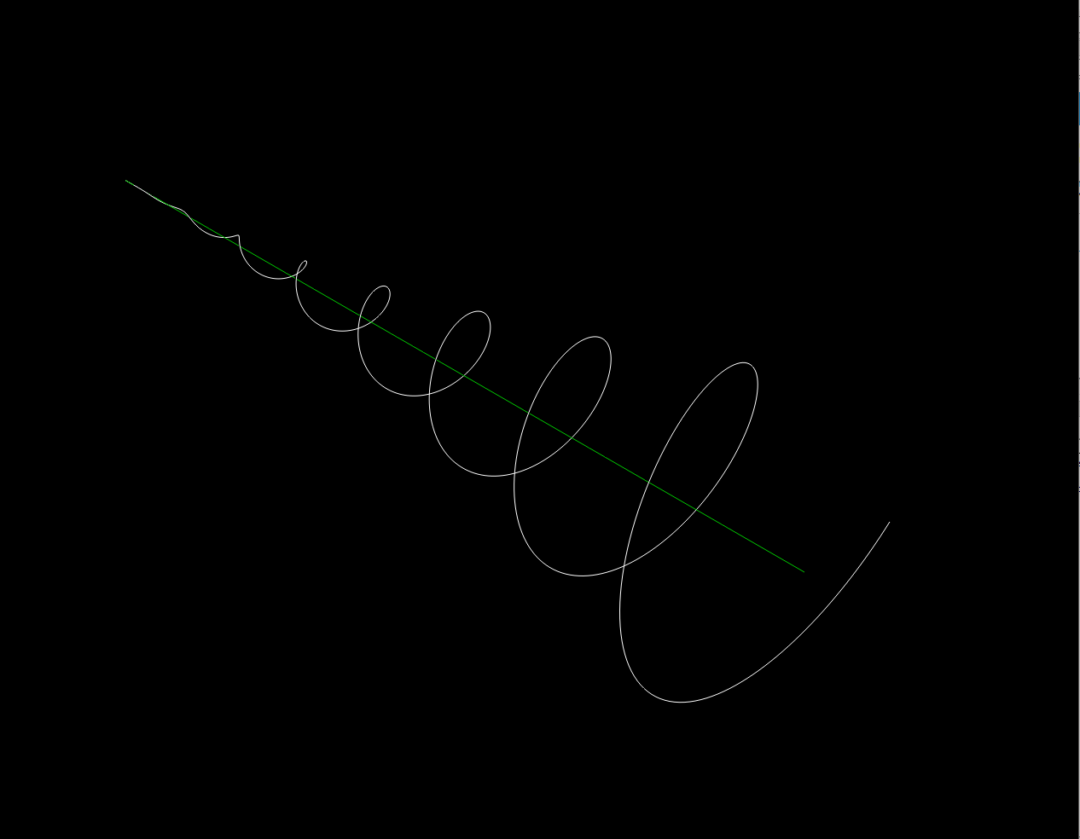

Figure 5: Isometric view of vortex points and vortex line.

Above, the isometric view better shows the relationship between the vortex cone and the vortex line. As the vortex grows in size, it remains centered on the vortex line. This vortex line can then be used to calculate a line integral, which results in the total force that the vortex exerts on the air around it.

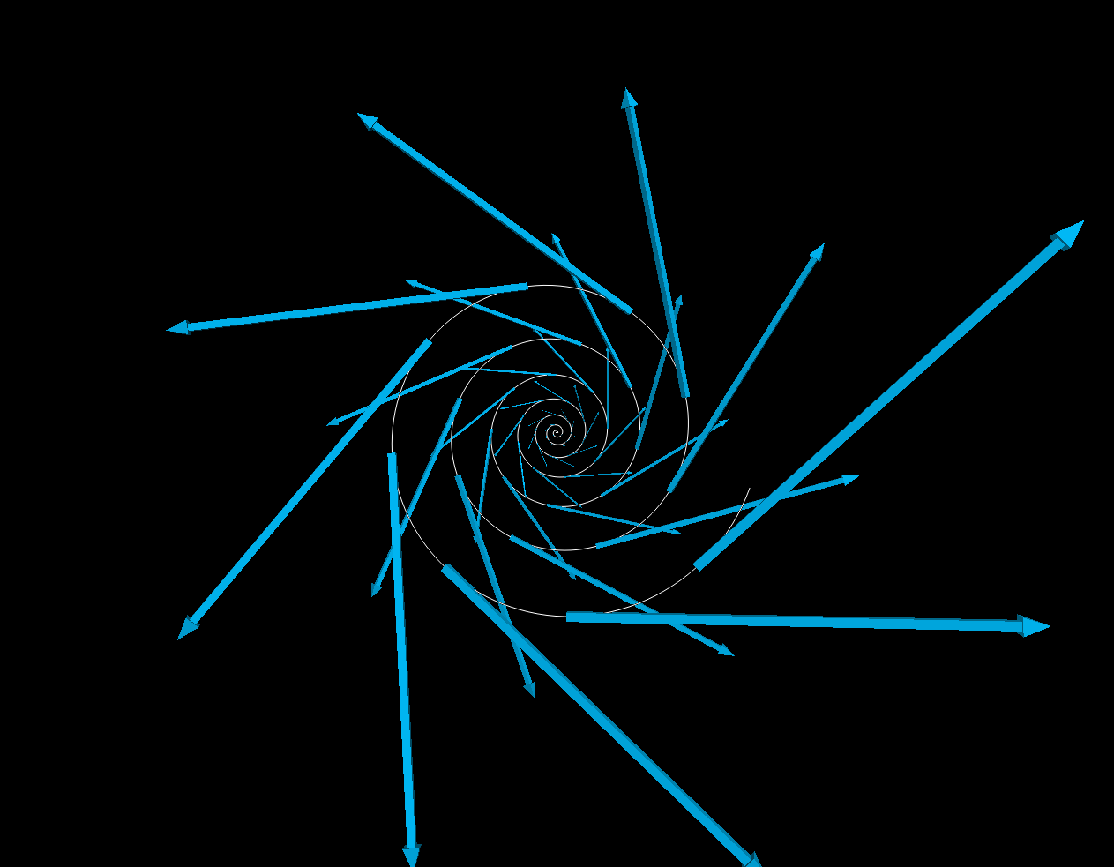

Figure 6: Frontal view of vortex points, vortex line, and velocity vectors.

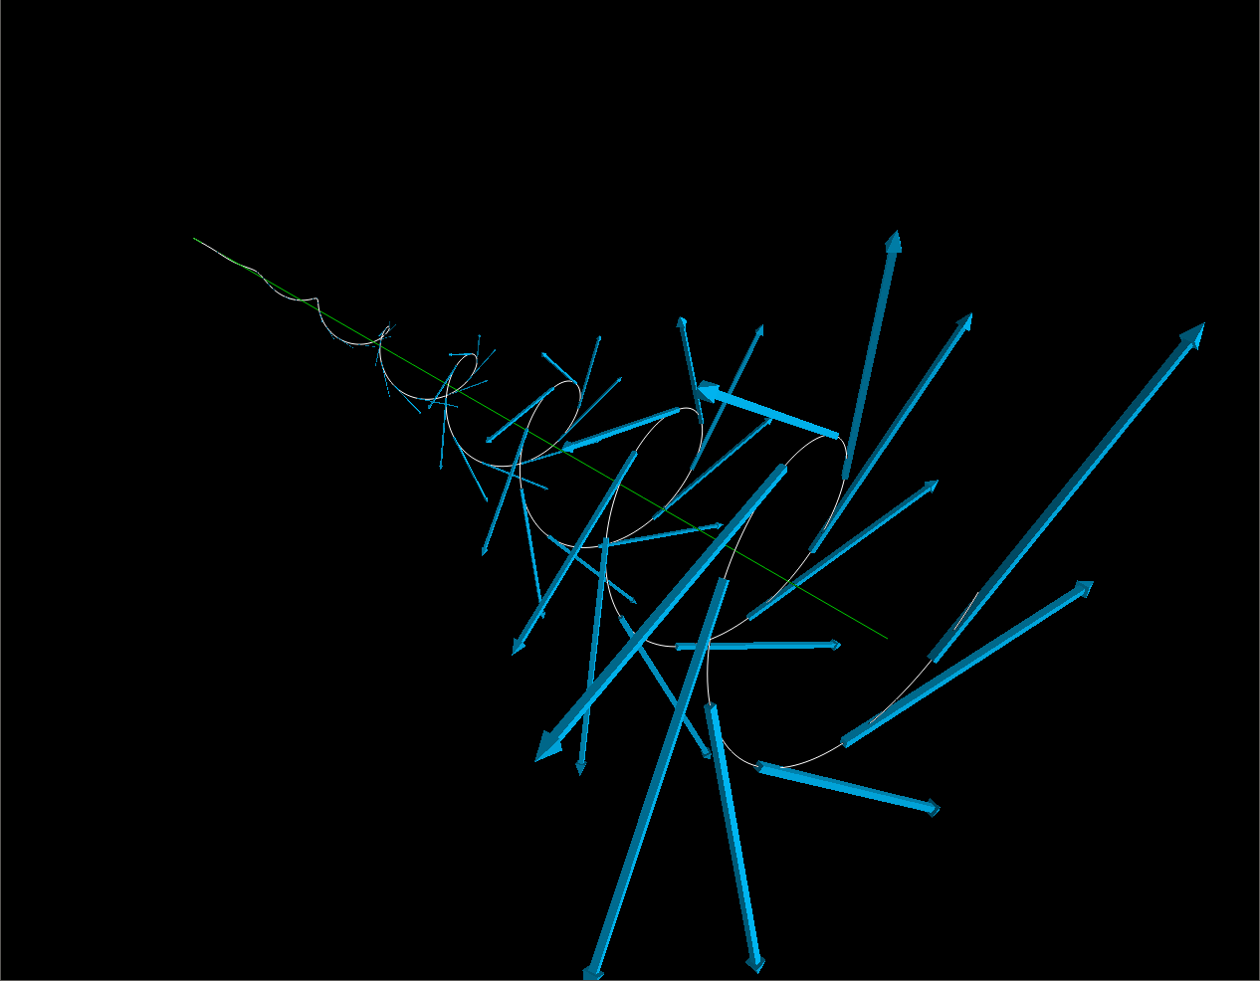

Figure 7: Isometric view of vortex points, vortex line, and velocity vectors.

The velocity vectors of the vortex were calculated every 75 points along the vortex and exhibit growth as the vortex itself grows. The increase in length of the vectors indicate that the velocity is tangential to the vortex and grows over space and time. The final visualization shown in Figure 7 shows the vortex itself, the vortex line indicating its direction and path that it follows, and velocity vectors that reveal the speed and direction of the flow of the fluid particles along this vortex.

# Verification

In order to verify the vortex’s shape and size, the initial velocity and pressure difference can be calculated using the last 2 points in the vortex. The initial velocity is calculated with the difference between the z position of the last 2 points, where *C2* is a scaling factor for visualization purposes. The intial pressure difference is calculated as a difference of radii over time where *C3* is also a scaling factor for visualization purposes.

$$v_{inlet }=\left(z_{i}-z_{i-1}\right)C_{2}$$

$$dP=\frac{\left(r_{i}-r_{i-1}\right)h}{C_{3}\left(t_{i}-t_{i-1}\right)t_{i}}$$

With the base case simulation, the above verification calculations results in the original *dP* and *vinlet*values that were defined.

Initial Freestream Velocity: 165.0 mph

Initial Pressure Difference: 2.99969993999

The initial freestream calculation results in the correct value, however, there is a slight difference in the pressure difference, which was defined as *dP = 3*. This is likely due to rounding error in the use of floating point values in these calculations. Despite the error, the value is still quite close to the initial value. This verification shows that the initial values are properly propagated and that using Runge-Kutta does not induce any numerical errors.

# Conclusions

This numerical study of a base case of a wingtip vortex confirms that the vortex shape and size depend on pressure difference and freestream velocity. A greater pressure difference will cause a larger and stronger vortex while a higher freestream velocity will generate a vortex that extends out further. Although this study focused primarily on a vortex generated almost purely from geometry as opposed to the Navier-Stokes equations, it still exhibits features that confirm that this vortex will behave similarly to those calculated from the Navier-Stokes equations. The vortex line reveals the direction of the vortex and easily allows the user to see where the vortex has been as well as where it is heading. Velocity vectors show that the flow along the vortex path grow in magnitude and remains tangential at all points.

# Future Work

Since this project focused primarily on the base case with a vortex that grew along the z-axis. In more realistic cases, the vortex shifts downwards due to gravity as well as outwards, depending on the direction of the pressure difference. This would require a much more complex analysis involving the Navier-Stokes equations with the appropriate boundary conditions to evaluate, which can also be numerically solved using fourth order Runge-Kutta.

Coupled with a numerical study of the position of a fluid particle along the vortex is the calculation of the vortex line, along which a line integral can be calculated. In this base case, the vortex line was known to follow the z-axis, but in more complex cases that shift due to gravity and other forces, the position of the vortex line for each z-coordinate will not be known.

# References

[1] Anderson, Elgin A., et al. *Experimental Study of the Structure of a Wingtip Vortex.* Utah State University, 2000.

[2] Devenport, William., et al. *The Structure and Development of a Wing-tip Vortex*. Virginia Polytechnic Institute and State University, 1996.

[3] Edstrand, Adam M., et al. *On the Stability and Control of a Trailing Vortex*. Florida State University, 2016.

[4] Kundu, Pijush K., et al. *Fluid Mechanics.* 6th ed., Academic Press, 2015.

[5] White, Frank M. *Viscous Fluid Flow*. 3rd ed., McGraw-Hill Higher Education, 2006.